# **What is a hydrophone?**

## A hydrophone is an underwater device that detects and records **ocean sounds** from all directions.

Just as a microphone collects sound in the air, a hydrophone detects acoustic signals under the water. Most hydrophones are based on a special property of certain ceramics that produces a small electrical current when subjected to changes in underwater pressure. When submerged in the ocean, a ceramic hydrophone produces small-voltage signals over a wide range of frequencies as it is exposed to underwater sounds emanating from any direction.

By amplifying and recording these electrical signals, hydrophones measure ocean sounds with great precision

Hydrophones listen to sounds in the sea, but do not transmit any sound, making them passive listening devices.

Most hydrophones are made from a [piezoelectric material](https://dosits.org/glossary/piezoelectric-material/). This material produces small electrical charges when exposed to [pressure](https://dosits.org/glossary/pressure/) changes. The pressure changes associated with a sound [wave](https://dosits.org/glossary/wave/) can be detected by a piezoelectric element. Under the pressure of a sound wave, the piezoelectric element flexes and in return gives off electrical signals. These electrical signals can be recorded and later analyzed with computer programs. [hydrophones](https://www.seis-tech.com/category/hydrophones/) convert sound in water into electrical signals that can be amplified, recorded, played back over loudspeakers, and used to measure the characteristics of the sound.

Some hydrophones, called [omnidirectional](https://dosits.org/glossary/omnidirectional/) hydrophones, record sounds from all directions with equal sensitivity. Other hydrophones, called [directional](https://dosits.org/glossary/directional/) hydrophones, have a higher sensitivity to signals from a particular direction. Directional hydrophones are typically us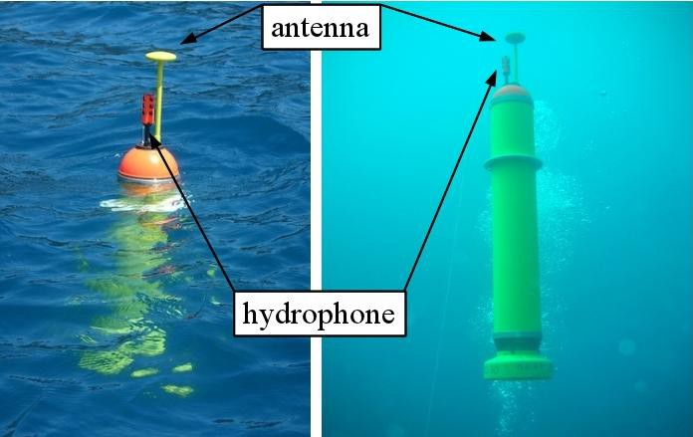ed in systems for locating and tracking objects.

Acoustic waves are fundamentally sound waves in any medium. Water is an [elastic medium](https://www.sciencedirect.com/topics/physics-and-astronomy/elastic-media) and any disturbance in the water is propagated from its origin as a wave. When water molecules are pushed or broken apart, they apply a restoring force that resists the motion. The force is locally felt as pressure/force per unit. The fundamental parameters of an acoustic wave are pressure and frequency [[48](https://www.sciencedirect.com/science/article/pii/S0924424721002533#bib0240)]. Functionally, the pressure variations of acoustic waves along with the ambient sea or other noises in the detectable [frequency bandwidth](https://www.sciencedirect.com/topics/engineering/frequency-bandwidth) reach the vector hydrophone or hydrophone array, then they are converted to electric/optical signals by the hydrophone. By processing the acoustic (field) information received by the hydrophone, the existence of the target and its other status features can be determined. It may also be useful to characterize the distribution of an acoustic field. Consequently, the required information about the target or field can be provided.

Performance Specifications

|  | |  | |
| --- | --- | --- | --- |
|  | **Frequency Response** |  | Frequency Response is the range of frequencies for which the microphone maintains a constant sensitivity within defined boundaries. Variation from this "linear" or "flat" sensitivity is given in dB; bounds that the define the linear frequency response will be in the form of ±3dB, -1dB/+4dB, etc. |
|  |  |  |  |
|  | | | |
|  | **Hydrophone Sensitivity:** |  | Typical values range between -220 and -150; more negative values represent lower sensitivity. |
|  |  |  |  |
|  | | | |
|  | **Maximum Operating Depth:** |  | This is the maximum depth for rated operation. Typically a "survival depth" will also be given that is significantly greater. |
|  |  |  |  |
|  | | | |
|  | **Operating Temperature:** |  | The temperature range over which the device must operate. |
|  |  |  |  |
|  |  |  |  |

Features

|  | |  | |
| --- | --- | --- | --- |
|  |  |  |  |
|  |  |  |  |
|  | | | |
|  | **Acceleration Noise Compensated?** |  | This compensation is designed to cancel or reduce noise generated from hydrophone movement underwater. |
|  |  |  |  |
|  | | | |
|  | **Array?** |  | An array is a set of hydrophones wired together in series or parallel and typically towed underwater. In the case of arrays, sensitivity ratings are given for the individual hydrophones that are part of the array. |
|  |  |  |  |
|  | | | |
|  | **Number of Hydrophones (Array only):** |  |  |
|  |  |  |  |
|  |  |  |  |

**• Sensitivity:** Hydrophones are basically just waterproof contact mics, so in general, hydrophones are very sensitive to touch. Be careful when it’s connected to your recorder - a hard hit might overload the input and potentially damage your circuitry. Depending on what you’re recording, you may have to crank your gain to get a good level.

**• Impedance:** Many hydrophones are high impedance and need to be converted to work with a standard microphone preamp. I mainly use an Aquarian H2a hydrophone, which doesn’t require any conversion. Make sure you know what your microphone needs before you head out to record.

# 

Hydrophone Signal Processing Board

The hydrophone signal processing board is designed to process the signals from two hydrophones or other sensors in parallel

These parameters and their desired values for a high performance hydrophone are as follows: Low size, high sensitivity, high free-field voltage sensitivity (FFVS), high noise resolution, large [signal to noise ratio](https://www.sciencedirect.com/topics/engineering/signal-to-noise-ratio) (SNR), large dynamic range, high [bandwidth](https://www.sciencedirect.com/topics/physics-and-astronomy/bandwidth), good linearity, and high spatial resolution. Also, important physical aspects that affect the device performance such as the [spatial averaging](https://www.sciencedirect.com/topics/engineering/spatial-averaging), cable effect, hydrostatic pressure, and [acoustic impedance](https://www.sciencedirect.com/topics/engineering/acoustic-impedance) matching to the liquid medium need to be paid attention.

Using efficient fabrication methods instead of processes that are chieﬂy responsible for the cost and difﬁculty is another requirement [[58](https://www.sciencedirect.com/science/article/pii/S0924424721002533#bib0290)]. Packaging or [encapsulation](https://www.sciencedirect.com/topics/physics-and-astronomy/encapsulation) is also one of the essential issues in the development of hydrophones that has a direct impact on the sensitivity.

## **Array Hydrophones**

Array hydrophones (streamers - built of multiple transducers) are all wired to receive a large sound signal collectively. The transducers are packed together in a tube with oil, which aids the collection of pressure waves entering the hydrophone. Pre-amplifiers are often used to enhance the electrical signal and limit the potential of noise contamination from additional components to the hydrophone.

A useful parameter in choosing piezoelectric materials to be used in hydrophones is the voltage coefficient, which links the electric field and the applied hydrostatic strain.